### Semester Two Examination, 2017

### Question/Answer booklet

# MATHEMATICS

**SOLUTIONS**

**METHODS**

**UNITS 1 AND 2**

## Section One:

## Calculator-free

|  |  |  |  |  |  |  |  |  |  |  |
| --- | --- | --- | --- | --- | --- | --- | --- | --- | --- | --- |
| Student Number: In figures |  |  |  |  |  |  |  |  |  |  |

In words

Your name

## Time allowed for this section

Reading time before commencing work: five minutes

Working time: fifty minutes

## Materials required/recommended for this section

***To be provided by the supervisor***

This Question/Answer booklet

Formula sheet

***To be provided by the candidate***

Standard items: pens (blue/black preferred), pencils (including coloured), sharpener, correction fluid/tape, eraser, ruler, highlighters

Special items: nil

## Important note to candidates

No other items may be taken into the examination room. It is **your** responsibility to ensure that you do not have any unauthorised material. If you have any unauthorised material with you, hand it to the supervisor **before** reading any further.

## Structure of this paper

|  |  |  |  |  |  |
| --- | --- | --- | --- | --- | --- |
| Section | Number of questions available | Number of questions to be answered | Working  time (minutes) | Marks available | Percentage of examination |
| Section One:  Calculator-free | 8 | 8 | 50 | 52 | 35 |
| Section Two:  Calculator-assumed | 13 | 13 | 100 | 98 | 65 |
|  | | |  | **Total** | 100 |

## Instructions to candidates

1. The rules for the conduct of examinations are detailed in the school handbook. Sitting this examination implies that you agree to abide by these rules.

2. Write your answers in this Question/Answer booklet.

3. You must be careful to confine your response to the specific question asked and to follow any instructions that are specified to a particular question.

4. Additional working space pages at the end of this Question/Answer booklet are for planning or continuing an answer. If you use these pages, indicate at the original answer, the page number it is planned/continued on and write the question number being planned/continued on the additional working space page.

5. Show all your working clearly. Your working should be in sufficient detail to allow your answers to be checked readily and for marks to be awarded for reasoning. Incorrect answers given without supporting reasoning cannot be allocated any marks. For any question or part question worth more than two marks, valid working or justification is required to receive full marks. If you repeat any question, ensure that you cancel the answer you do not wish to have marked.

6. It is recommended that you do not use pencil, except in diagrams.

7. The Formula sheet is not to be handed in with your Question/Answer booklet.

Section One: Calculator-free 35% (52 Marks)

This section has**eight (****8)** questions. Answer **all** questions. Write your answers in the spaces provided.

Working time: 50 minutes.

Question 1 (5 marks)

(a) Determine $f'(x)$ if

(i) $f\left(x\right)={5x}^{4}+x$. (1 mark)

|  |
| --- |
| **Solution** |
| $$f^{'}\left(x\right)=20x^{3}+1$$ |
| **Specific behaviours** |
| ✓ differentiates |

(ii) $f\left(x\right)={\left(2x+3\right)}^{2}$. (2 marks)

|  |
| --- |
| **Solution** |
| $$f\left(x\right)=4x^{2}+12x+9$$ $$f^{'}\left(x\right)=8x+12$$ |
| **Specific behaviours** |
| ✓ expands  ✓ differentiates |

(b) The area of an oil slick, at time $t$ hours, is given by $A\left(t\right)=0.5t^{3}-2t^{2}+7$ square meters. Determine the instantaneous rate of change of the area of the slick when $t=10$ hours.

(2 marks)

|  |
| --- |
| **Solution** |
| $$A^{'}\left(t\right)=1.5t^{2}-4t$$ $$A^{'}\left(10\right)=150-40=110 {\text{m}}^{2}\text{/h}$$ |
| **Specific behaviours** |
| ✓ differentiates correctly  ✓ substitutes and simplifies |

Question 2 (8 marks)

**(a)** Determine the antiderivative of the following. Leave your answers with positive indices where necessary.

**(i)** 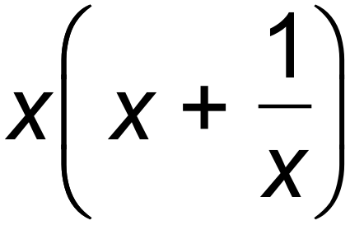 where 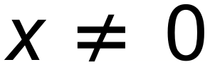 (2 marks)

(i) 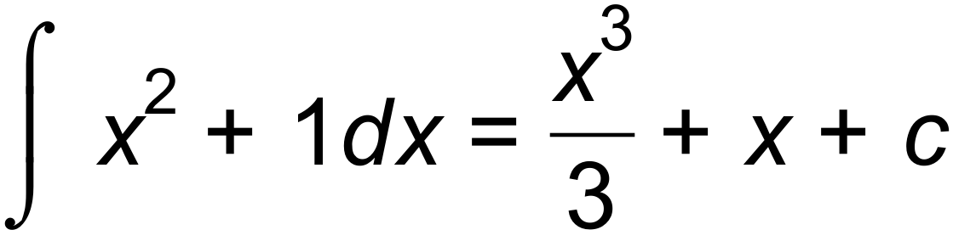 ✓✓

One mark for integrating

One mark for constant(even if integration is wrong)

**(ii)** 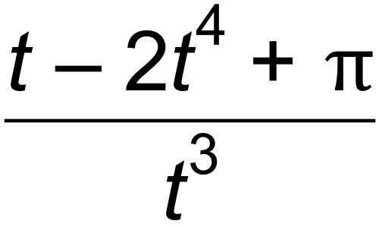 (3 marks)

(ii) 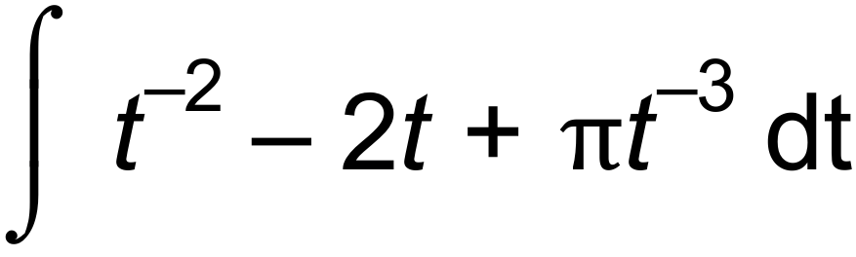 ✓

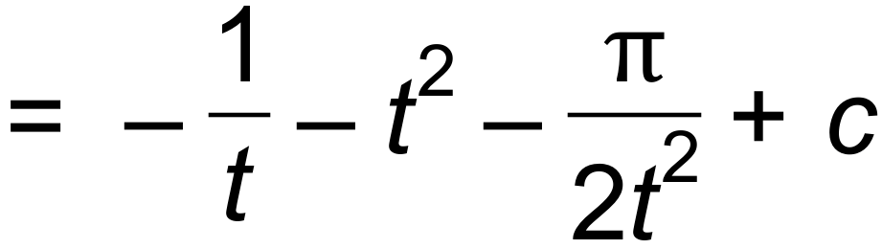 ✓✓

One mark integrating

One mark positive powers

One mark constant(But only if integration is correct-no need for positive powers)

**(b)** Find 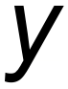 in terms of  for 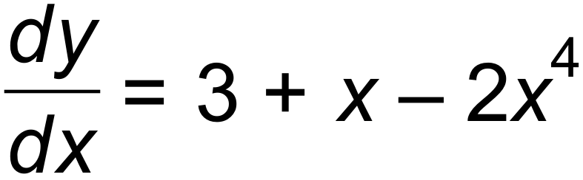, and 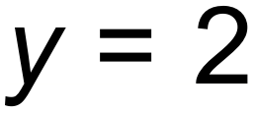 when 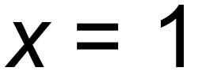. (3 marks)

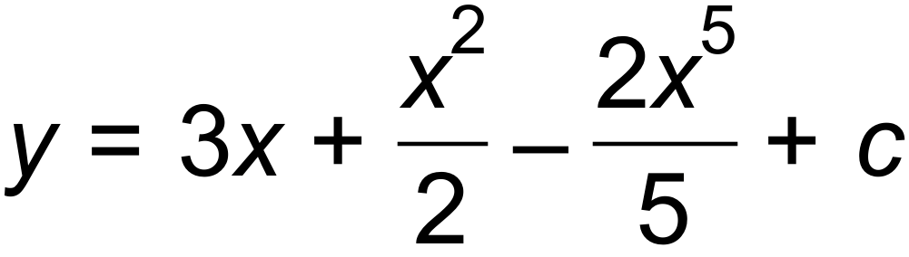 ✓

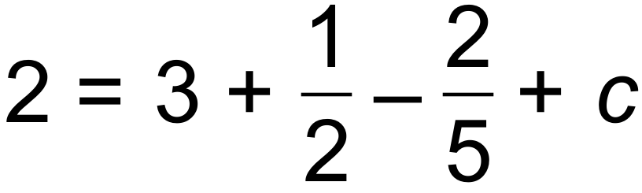

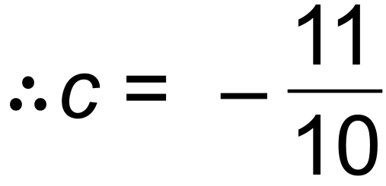 ✓

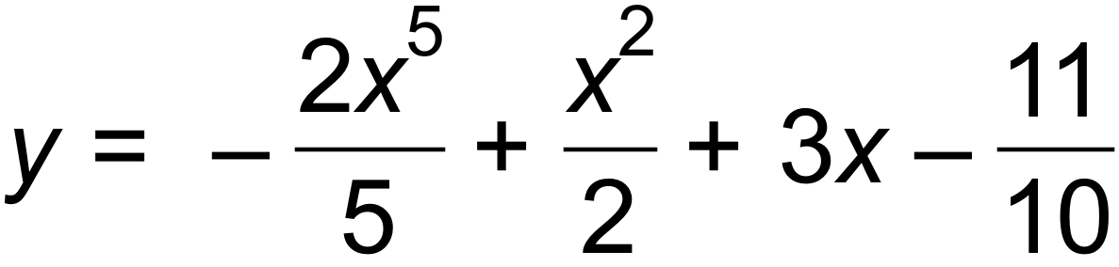 ✓

One mark integration

One mark for constant

One mark finding constant(follow through)

Question 3 (5 marks)

(a) Evaluate $x^{2a}÷x^{b}$ when $x=16$, $a=1.5$ and $b=3.5$. (3 marks)

|  |
| --- |
| **Solution** |
| $${2x}^{a-b}={16}^{-\frac{1}{2}}$$ $$=\frac{1}{\sqrt{16}}$$ $$=\frac{1}{4}$$ |
| **Specific behaviours** |
| ✓ eliminates negative indices  ✓ eliminates fractional indices  ✓ states value |

(b) Solve for x

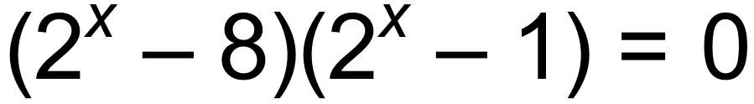 (2 marks)

x=0,3

One mark for each answer

Question 4 (7 marks)

Solve the following equations for $x$:

(a) $2\sin{x}+1=0, 0≤x≤360°$. (2 marks)

|  |
| --- |
| **Solution** |
| $$\sin{x}=-\frac{1}{2}⇒x=210°, 330°$$ |
| **Specific behaviours** |
| ✓ determines one solution  ✓ determines both solutions |

(b) $\begin{matrix}x+4 \\ \overline{x-3}\end{matrix}=\begin{matrix}3 \\ \overline{4}\end{matrix}$. (2 marks)

|  |
| --- |
| **Solution** |
| $$4\left(x+4\right)=3\left(x-3\right)$$ $$4x+16=3x-9$$ $$x=-25$$ |
| **Specific behaviours** |
| ✓ cross multiplies and expands  ✓ correct solution |

(c) ${\left(3x-2\right)}^{2}-25=0$. (3 marks)

|  |
| --- |
| **Solution** |
| $${\left(3x-2\right)}^{2}=25$$ $$3x-2=±5$$ $$3x=7, -3$$ $$x=\frac{7}{3}, x=-1$$ |
| **Specific behaviours** |
| ✓ square roots both sides, with $±$ one side  ✓ solves for  ✓ correct solutions |

Question 5 (8 marks)

The graph of $y=ax^{3}+bx+c$ has a stationary point at $(-1, 11)$ and a gradient of $48$ when $x=3$.

(a) Determine the values of the constants $a$, $b$ and $c$. (6 marks)

|  |
| --- |
| **Solution** |
| $$\frac{dy}{dx}=3ax^{2}+b \\ 0=3a{\left(-1\right)}^{2}+b⇒3a+b=0 \\ 48=3a{\left(3\right)}^{2}+b⇒27a+b=48 \\ 24a=48⇒a=2 \\ b=-3\left(2\right)=-6 \\ 11=2{\left(-1\right)}^{3}-6\left(-1\right)+c⇒c=7$$ $$a=2, b=-6, c=7$$ |
| **Specific behaviours** |
| ✓ differentiates equation  ✓ equation using $y^{'}=0$ when  ✓ equation using $y^{'}=48$ when  ✓ determines value of  ✓ determines value of  ✓ uses $(-1, 11)$ to determine $c$ |

(b) Determine the coordinates of any other stationary points. (2 marks)

|  |
| --- |
| **Solution** |
| $$\frac{dy}{dx}=-6x^{2}-6 \\ =0 \text{when} x=±1$$ $$2{\left(1\right)}^{3}-6\left(1\right)+7=3$$ $$\text{Other SP at} (1, 3)$$ |
| **Specific behaviours** |
| ✓ determines other $x$-coordinate  ✓ states coordinates |

Question 6 (7 marks)

(a) Solve for x. (3 marks)

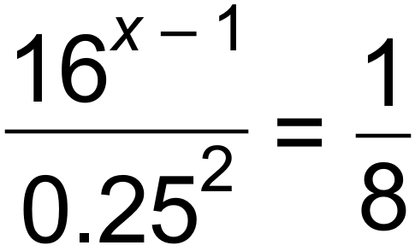

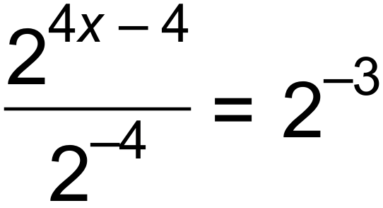 ✓

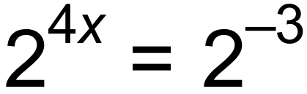 ✓

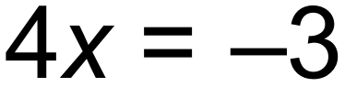

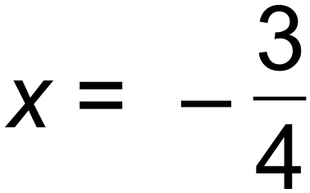 ✓

One mark for simplifying to one term

One mark for equating powers

One mark for solving for x

(b) Consider the equation $x^{3}-7x^{2}+36=0$.

(i) Show that $x=3$ is a solution of the equation. (1 mark)

|  |
| --- |
| **Solution** |
| $$27-63+36=63-63=0$$ |
| **Specific behaviours** |
| ✓ substitutes and expands |

(ii) Determine all other solutions. (3 marks)

|  |
| --- |
| **Solution** |
| $$x^{3}-7x^{2}+36=\left(x-3\right)\left(x^{2}-4x-12\right) \\ =\left(x-3\right)\left(x+2\right)\left(x-6\right)$$ $$\text{Other solutions}:x=-2, x=6$$ |
| **Specific behaviours** |
| ✓ determines quadratic factor  ✓ factorises cubic  ✓ states other two solutions |

Question 7 (6 marks)

The function 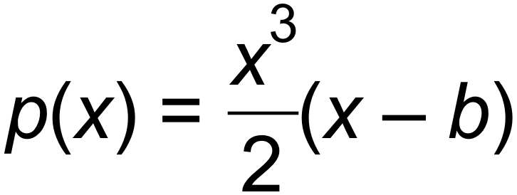 is shown below.

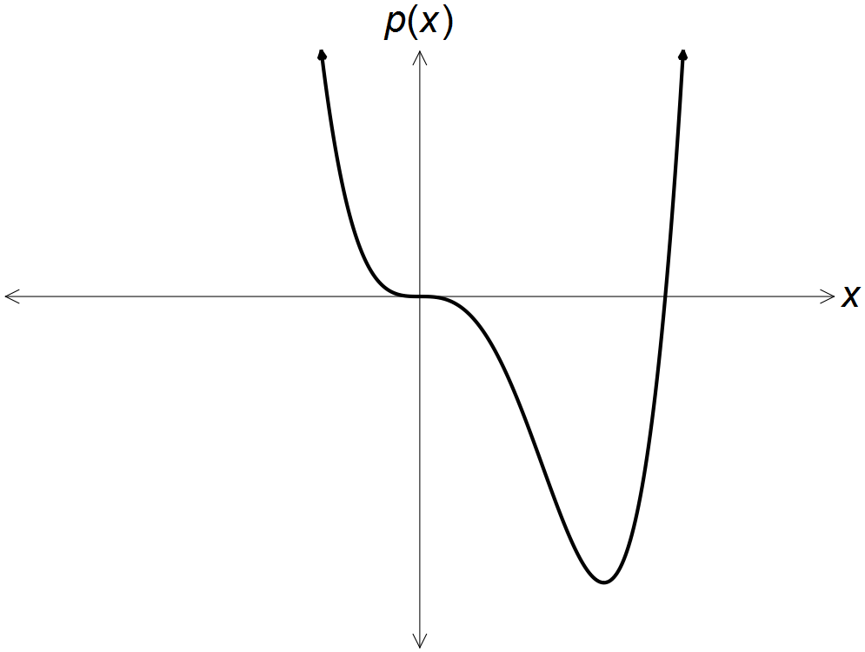

**(a)** Given 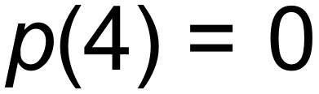, show that *b* = 4. (1 mark)

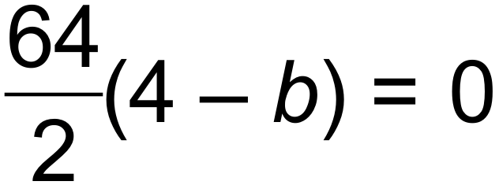

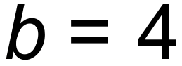 ✓

**(b)** Find the co-ordinates of the local minimum. (3 marks)

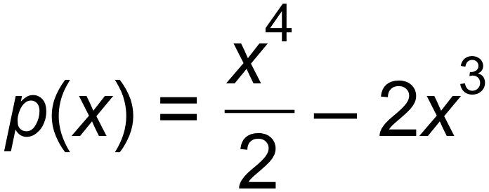

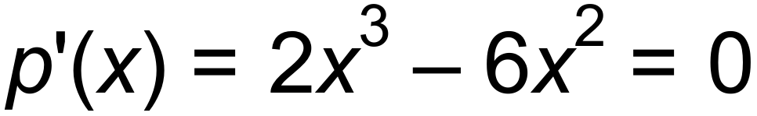 ✓

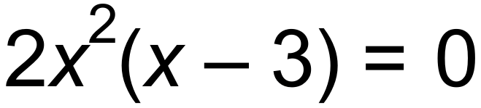

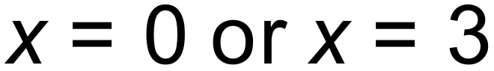 (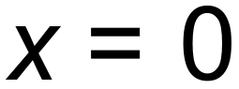 is not a minimum) ✓

When 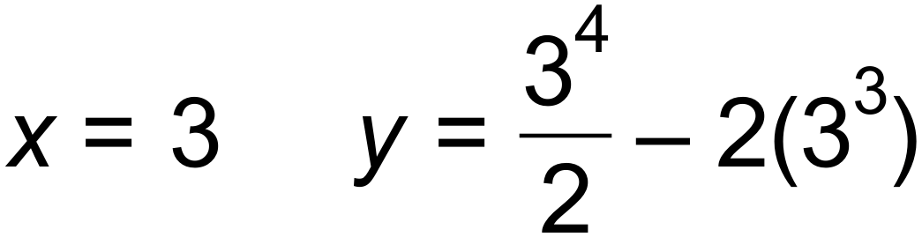

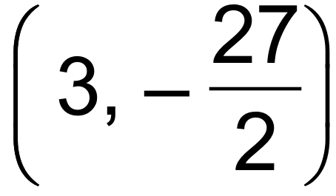 ✓

**(c)** Show that there is a horizontal point of inflection at . (2 marks)

Stationary point at 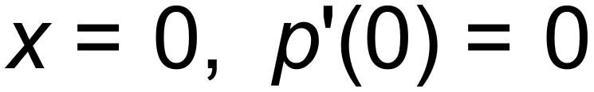

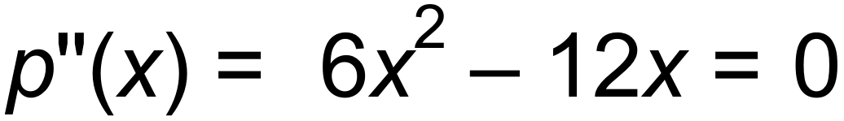 ✓

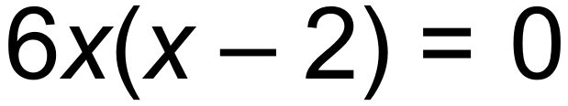

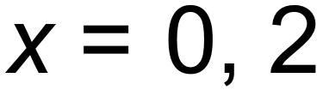

 ✓ [6]

Horizontal point of inflection

Or sign table:

|  |  |  |  |  |  |
| --- | --- | --- | --- | --- | --- |
|  |  |  |  |  |  |
|  | $$↓$$ | $$↔$$ | $$↓$$ | $$↔$$ | $$↑$$ |
|  | - | 0 | - | 0 | + |

Question 8 (6 marks)

The graph of the function $y=f(x)$ is shown below, where

$$f\left(x\right)=\frac{5}{x-1}.$$

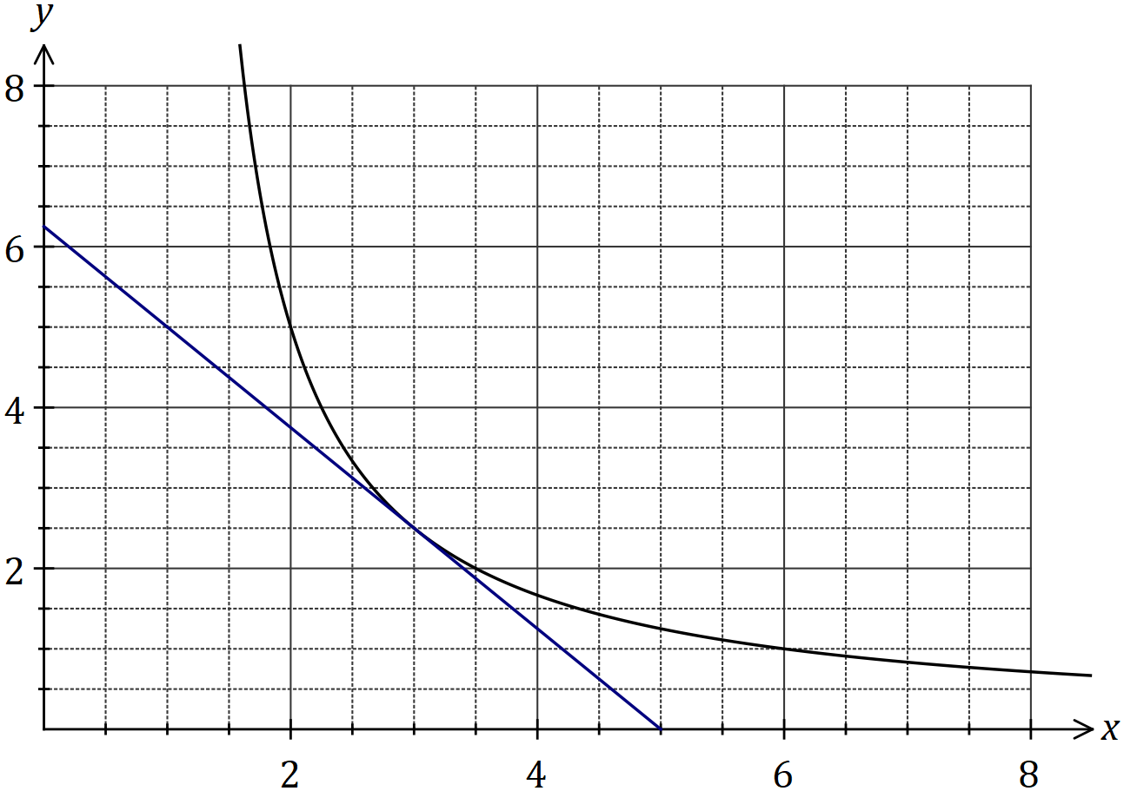

(a) Draw the tangent to the graph at $x=3$ so that it cuts both axes, and use the tangent to estimate the value of $f'(3)$. (3 marks)

|  |
| --- |
| **Solution** |
| See graph. Slope of tangent $≈-\frac{6}{5}≈-1.2$ |
| **Specific behaviours** |
| ✓ tangent drawn as straight line  ✓ tangent cuts $y$-axis between 5.5 and 7  ✓ estimate of gradient of tangent |

(b) Calculate the average rate of change of the function as $x$ increases from $3$ to $3.5$.

(3 marks)

|  |
| --- |
| **Solution** |
| $$f\left(3\right)=2.5, f\left(3.5\right)=2$$ $$\text{ARoC}=\frac{2-2.5}{3.5-3}=\frac{-0.5}{0.5}=-1$$ |
| **Specific behaviours** |
| ✓ calculates change in $x$-coordinates  ✓ calculates change in $y$-coordinates  ✓ states correct gradient |

Additional working space

Question number: _________